Lab 09: Patch metrics
Ryan Reisinger
2025-12-10

Introduction
Today we will look at a short example of using the landscapemetrics R package to calculate patch metrics from raster data. Remember, patch metrics are measures of the size, shape, and configuration of patches of habitat. This applies to the patch-mosaic and patch matrix models.
The package implements metrics from a computer programme called FRAGSTATS (https://www.fragstats.org/), which is widely used in landscape ecology. The package can calculate a wide variety of landscape metrics at the patch, class, and landscape levels.
The package’s website has some general background: https://r-spatialecology.github.io/landscapemetrics/articles/general_background.html
The paper describing the package can be found here: https://doi.org/10.1111/ecog.04617
# Load packages
library(terra)
## terra 1.8.70
library(landscapemetrics)
library(dplyr)
##
## Attaching package: 'dplyr'
## The following objects are masked from 'package:terra':
##
## intersect, union
## The following objects are masked from 'package:stats':
##
## filter, lag
## The following objects are masked from 'package:base':
##
## intersect, setdiff, setequal, union
First, we’ll get some data. landscapemetrics has a few built-in datasets. Let’s use podlasie_ccilc, which is a land cover map of the Podlasie region of Poland. This is a 300 m resolution raster dataset with 5 land cover classes.
# Get landscape data
# The terra::unwrap() functions processes this kind of raster dataset
my_dat <- terra::unwrap(podlasie_ccilc)
plot(my_dat)
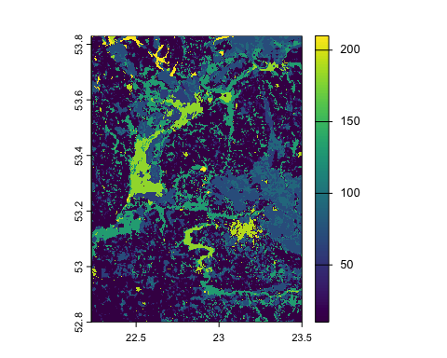
It’s recommended to first use the check_landscape() function to make sure your raster is in the right format.
The requirements to calculate meaningful landscape metrics are:
- The distance units of your projection are meters, as the package converts units internally and returns results in either meters, square meters or hectares. For more information see the help file of each function.
- Your raster encodes landscape classes as integers (1, 2, 3, 4, …, n).
- Landscape metrics describe categorical landscapes, that means that your landscape needs to be classified (the package throws a warning if you have more than 30 classes to make sure you work with a classified landscape).
check_landscape(my_dat)
## Warning: Caution: Coordinate reference system not metric - Units of results
## based on cellsizes and/or distances may be incorrect.
## layer crs units class n_classes OK
## 1 1 geographic degrees integer 14 ✖
✔ Our raster is categorical (it has integer values)
✖ It’s not in a projected coordinate system: the CRS is ‘geographic’ and the units are ‘degrees’ (it would be ‘meters’ if it was projected). Remember back to Lab 3. Let’s fix that. Choosing a coordinate reference system is quite specific, but let’s choose a global, general projection for this excercise. We’ll use the Robinson projection, which is a global projection that preserves area and shape. It’s not perfect, but it’s a good compromise for global data. I found the ‘proj4’ string for this projection on the https://epsg.io/53030 website. Note, we must set the method argument to equal near – nearest neighbour interpolation – otherwise when the reprojection occurs, the raster values will be changed from integer values to numeric values (remember from the line above, our raster must have integers, or whole numbers, representing the different classes).
# Use the project function to reproject the data
my_dat <- project(x = my_dat,
y = "+proj=robin +lon_0=0 +x_0=0 +y_0=0 +R=6371000 +units=m +no_defs +type=crs",
method = "near")
# You could also use the ESRI code from the site https://spatialreference.org/ref/esri/53030/ like this:
# my_dat <- project(x = my_dat,
# y = "ESRI:53030",
# method = "near")
Now check our landscape again:
check_landscape(my_dat)
## layer crs units class n_classes OK
## 1 1 projected m integer 14 ✔
plot(my_dat)
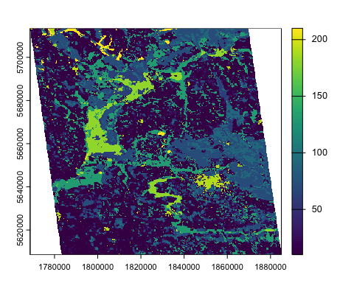
Notice that the axis values have changed (the map now has meter units) and the raster is a bit ‘skew’ because of the reprojection into a projected coordinate reference system.
We can also look at the patches using the show_patches function.
show_patches(my_dat)
## $layer_1
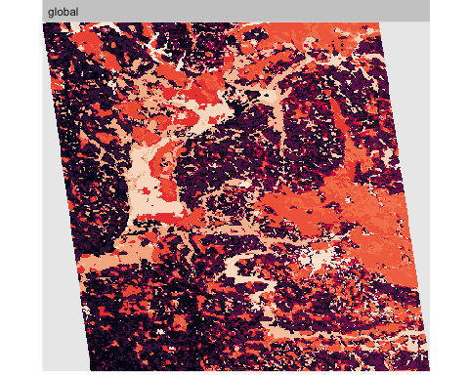
Now, we can calculate some metrics. From Lecture 4, recall that Table 2.1 and Table 2.2 in Pittman chapter 2 show metrics that we can calculate, or we can look in the paper Wedding et al. 2011.
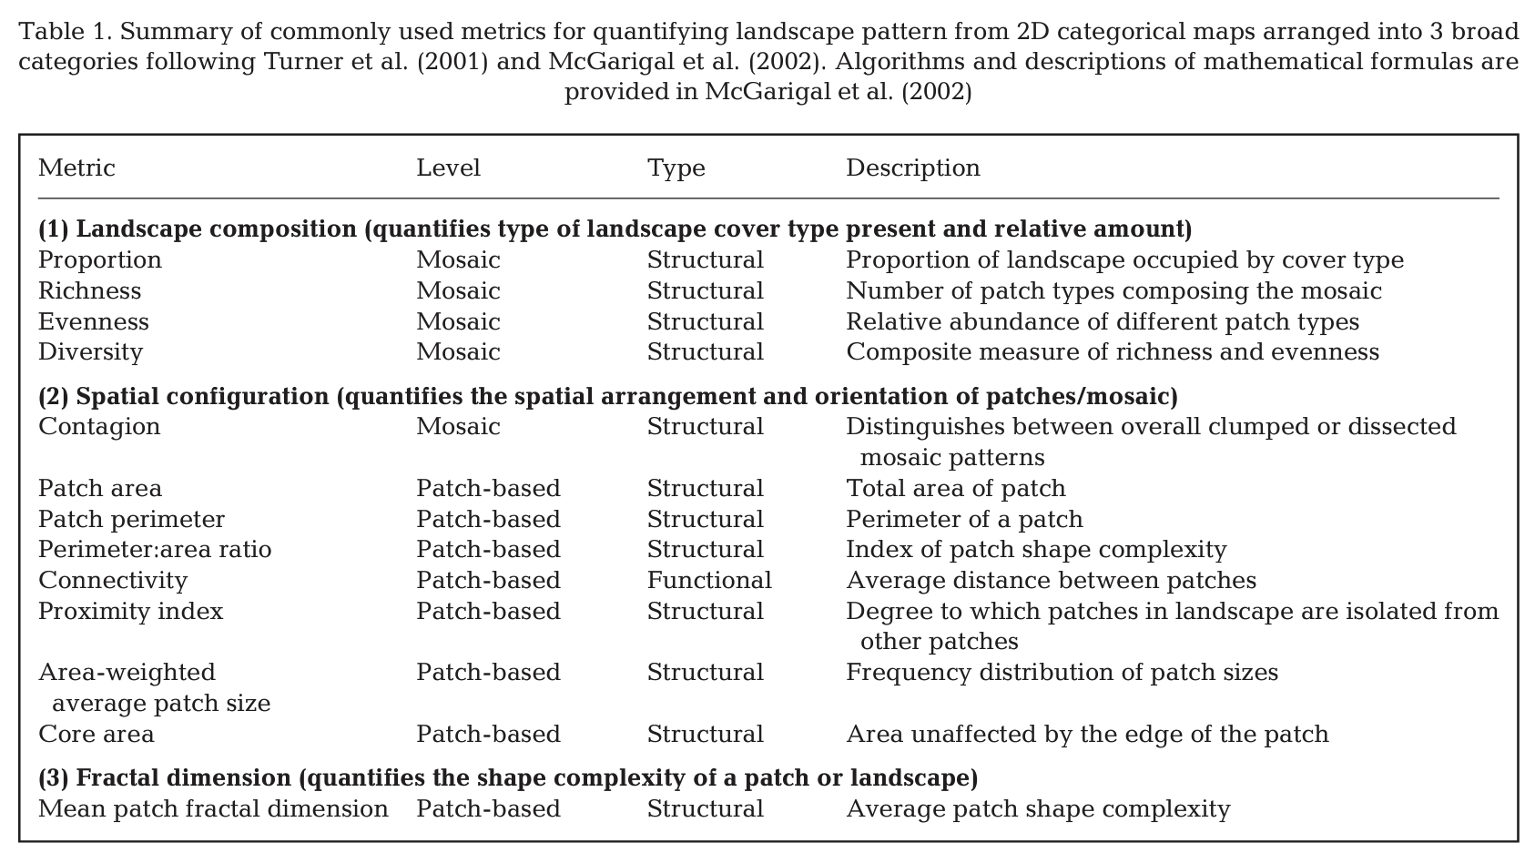
Table 1 from Wedding et al. (2011).
We can calculate patch-, class- and landscape-level metrics. All functions start with lsm_ prefix and then c, p, or l for ‘class’, ‘patch’ or ’landscape level, followed by the specific function:
For example, patch-level area:
# Patch-level
# This function calculates the area of each patch
patch_area <- lsm_p_area(my_dat)
patch_area
## # A tibble: 9,973 × 6
## layer level class id metric value
## <int> <chr> <int> <int> <chr> <dbl>
## 1 1 patch 10 1 area 1807.
## 2 1 patch 10 2 area 17207.
## 3 1 patch 10 3 area 7.09
## 4 1 patch 10 4 area 128.
## 5 1 patch 10 5 area 28.3
## 6 1 patch 10 6 area 135.
## 7 1 patch 10 7 area 14.2
## 8 1 patch 10 8 area 21.3
## 9 1 patch 10 9 area 14.2
## 10 1 patch 10 10 area 35.4
## # ℹ 9,963 more rows
# Let's do a bit more work to summarise the information returned
# We use dplyr to group the data table by class, then summarise the
# data, calculating the means, standard deviations, min and max values
# for each class
patch_area <- dplyr::group_by(patch_area, class)
patch_area <- dplyr::summarise(patch_area,
mean_area = mean(value),
sd_area = sd(value),
min_area = min(value),
max_area = max(value))
patch_area
## # A tibble: 14 × 5
## class mean_area sd_area min_area max_area
## <int> <dbl> <dbl> <dbl> <dbl>
## 1 10 201. 2073. 7.09 69942.
## 2 11 113. 311. 7.09 7130.
## 3 30 38.1 58.5 7.09 1417.
## 4 40 15.1 8.92 7.09 56.7
## 5 60 99.6 382. 7.09 5011.
## 6 61 18.3 10.3 7.09 49.6
## 7 70 243. 1167. 7.09 22891.
## 8 90 99.4 389. 7.09 6144.
## 9 100 27.1 26.8 7.09 234.
## 10 110 18.9 17.2 7.09 106.
## 11 130 135. 883. 7.09 16860.
## 12 180 392. 1990. 7.09 17661.
## 13 190 53.7 369. 7.09 5535.
## 14 210 154. 329. 7.09 1935.
# You can use the class level function to more quickly return the mean area, or the standard deviation,
mean_class_area <- lsm_c_area_mn(my_dat)
mean_class_area
## # A tibble: 14 × 6
## layer level class id metric value
## <int> <chr> <int> <int> <chr> <dbl>
## 1 1 class 10 NA area_mn 201.
## 2 1 class 11 NA area_mn 113.
## 3 1 class 30 NA area_mn 38.1
## 4 1 class 40 NA area_mn 15.1
## 5 1 class 60 NA area_mn 99.6
## 6 1 class 61 NA area_mn 18.3
## 7 1 class 70 NA area_mn 243.
## 8 1 class 90 NA area_mn 99.4
## 9 1 class 100 NA area_mn 27.1
## 10 1 class 110 NA area_mn 18.9
## 11 1 class 130 NA area_mn 135.
## 12 1 class 180 NA area_mn 392.
## 13 1 class 190 NA area_mn 53.7
## 14 1 class 210 NA area_mn 154.
sd_class_area <- lsm_c_area_sd(my_dat)
sd_class_area
## # A tibble: 14 × 6
## layer level class id metric value
## <int> <chr> <int> <int> <chr> <dbl>
## 1 1 class 10 NA area_sd 2073.
## 2 1 class 11 NA area_sd 311.
## 3 1 class 30 NA area_sd 58.5
## 4 1 class 40 NA area_sd 8.92
## 5 1 class 60 NA area_sd 382.
## 6 1 class 61 NA area_sd 10.3
## 7 1 class 70 NA area_sd 1167.
## 8 1 class 90 NA area_sd 389.
## 9 1 class 100 NA area_sd 26.8
## 10 1 class 110 NA area_sd 17.2
## 11 1 class 130 NA area_sd 883.
## 12 1 class 180 NA area_sd 1990.
## 13 1 class 190 NA area_sd 369.
## 14 1 class 210 NA area_sd 329.
Here’s an example of calculate something called fractal dimension at the patch level:
patch_fractal <- lsm_p_frac(my_dat)
patch_fractal
## # A tibble: 9,973 × 6
## layer level class id metric value
## <int> <chr> <int> <int> <chr> <dbl>
## 1 1 patch 10 1 frac 1.21
## 2 1 patch 10 2 frac 1.28
## 3 1 patch 10 3 frac 1
## 4 1 patch 10 4 frac 1.14
## 5 1 patch 10 5 frac 1.04
## 6 1 patch 10 6 frac 1.08
## 7 1 patch 10 7 frac 1.01
## 8 1 patch 10 8 frac 1.02
## 9 1 patch 10 9 frac 1.01
## 10 1 patch 10 10 frac 1.07
## # ℹ 9,963 more rows
Class-level metrics can be calculated similarly. For example:
# Total area of each class
total_class_area <- lsm_c_ca(my_dat)
total_class_area
## # A tibble: 14 × 6
## layer level class id metric value
## <int> <chr> <int> <int> <chr> <dbl>
## 1 1 class 10 NA ca 302502.
## 2 1 class 11 NA ca 191377.
## 3 1 class 30 NA ca 102315.
## 4 1 class 40 NA ca 1949.
## 5 1 class 60 NA ca 44910.
## 6 1 class 61 NA ca 475.
## 7 1 class 70 NA ca 148586.
## 8 1 class 90 NA ca 40049.
## 9 1 class 100 NA ca 26279.
## 10 1 class 110 NA ca 624.
## 11 1 class 130 NA ca 145354.
## 12 1 class 180 NA ca 39616.
## 13 1 class 190 NA ca 12360.
## 14 1 class 210 NA ca 7370.
# Percent of landscape of each class
percent_class_area <- lsm_c_pland(my_dat)
percent_class_area
## # A tibble: 14 × 6
## layer level class id metric value
## <int> <chr> <int> <int> <chr> <dbl>
## 1 1 class 10 NA pland 28.4
## 2 1 class 11 NA pland 18.0
## 3 1 class 30 NA pland 9.62
## 4 1 class 40 NA pland 0.183
## 5 1 class 60 NA pland 4.22
## 6 1 class 61 NA pland 0.0446
## 7 1 class 70 NA pland 14.0
## 8 1 class 90 NA pland 3.76
## 9 1 class 100 NA pland 2.47
## 10 1 class 110 NA pland 0.0586
## 11 1 class 130 NA pland 13.7
## 12 1 class 180 NA pland 3.72
## 13 1 class 190 NA pland 1.16
## 14 1 class 210 NA pland 0.693
Landscape-level metrics are calculated without grouping by class or patch. For example, landscape-level ‘contagion’ (https://www.fragstats.org/index.php/fragstats-metrics/patch-based-metrics/aggregation-metrics/l1-contagion-index):
# Landscape-level
landscape_contagion <- lsm_l_contag(my_dat)
landscape_contagion
## # A tibble: 1 × 6
## layer level class id metric value
## <int> <chr> <int> <int> <chr> <dbl>
## 1 1 landscape NA NA contag 39.7
# Note that landscape-level metrics return a single value
You can calculate many different metrics. See the package documentation for a full list: https://r-spatialecology.github.io/landscapemetrics/reference/index.html
More information on each of the metrics is on the FRAGSTATS page at https://www.fragstats.org/index.php/documentation (navigate to the metrics using the navigation on the left hand side of the web page)
Let’s try an example of looking at some metrics for a seascape.
We can use data from something called the EUSeaMap 2025 Broad-Scale Predictive Habitat Map for Europe. More information is given here:
https://emodnet.ec.europa.eu/geonetwork/srv/eng/catalog.search#/metadata/cec07b5e-3a9c-4492-b115-126a17c08697
You can use their viewer to explore and download the data (https://emodnet.ec.europa.eu/geoviewer/#).
However, I did the following
- I went to the data catalogue: https://emodnet.ec.europa.eu/geonetwork/srv/eng/catalog.search
- I then searched for “EUSeaMap 2025 Broad-Scale Predictive Habitat Map for Europe”
- Under filters, I selected ‘Type of Resource’ = ‘Dataset’, which returned 5 datasets
- I chose the first dataset and clicked on download icon, which let me download a zip file of the data
- The direct link is: files.emodnet-seabedhabitats.eu/data/EUSeaMap_2025.zip
- I unzipped the file, and from there found the raster called “habitat_eunis2007_confidence_overall_2025.tif”
- I saved that file in my working directory, in a subfolder called ‘data’.
- Let’s go from there…
# Load the seascape data
seascape <- terra::rast("data/habitat_eunis2007_confidence_overall_2025.tif")
# This is a really gigantic raster, so let's crop it to a smaller area
# Define an extent (xmin, xmax, ymin, ymax) in decimal degrees
seascape_crop <- ext(-10, +0, +50, +60)
# Crop the raster
seascape <- crop(seascape, seascape_crop)
# Plot to check
plot(seascape)
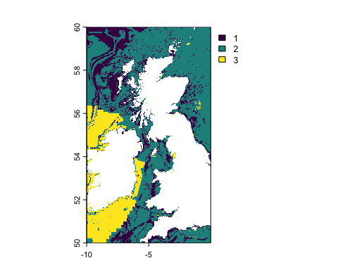
# Check the landscape
check_landscape(seascape)
## Warning: Caution: Coordinate reference system not metric - Units of results
## based on cellsizes and/or distances may be incorrect.
## layer crs units class n_classes OK
## 1 1 geographic degrees integer 3 ✖
# Our raster is categorical (it has integers for the classes), but it is not projected (the units are degrees). Let's reproject it to the Robinson projection (https://spatialreference.org/ref/esri/53030/) like we did before.
seascape <- project(x = seascape,
y = "ESRI:53030",
method = "near")
## |---------|---------|---------|---------|=========================================
# Check again
check_landscape(seascape)
## layer crs units class n_classes OK
## 1 1 projected m integer 3 ✔
# Now we can calculate some metrics
# Let's look at class-level metrics of total area and percent of landscape
total_class_area_seascape <- lsm_c_ca(seascape)
total_class_area_seascape
## # A tibble: 3 × 6
## layer level class id metric value
## <int> <chr> <int> <int> <chr> <dbl>
## 1 1 class 1 NA ca 10446961.
## 2 1 class 2 NA ca 28396269.
## 3 1 class 3 NA ca 8035927.
percent_class_area_seascape <- lsm_c_pland(seascape)
percent_class_area_seascape
## # A tibble: 3 × 6
## layer level class id metric value
## <int> <chr> <int> <int> <chr> <dbl>
## 1 1 class 1 NA pland 22.3
## 2 1 class 2 NA pland 60.6
## 3 1 class 3 NA pland 17.1
# Try calculating some metrics for yourself...

